Color Detection: How It Works
Sep 28, 2026 · @Johannes Grobbelaar

Overview
The program reads live webcam frames, finds every pixel close to a chosen color, and draws one bounding box around all of them. It exists in two versions that share the same algorithm:
- Python desktop version (main.py + util.py): the original. It uses OpenCV for capture, color conversion and drawing, NumPy for arrays, and Pillow for the bounding box. It tracks yellow only.
- Browser version (web/index.html): a port to plain JavaScript that runs in any modern browser. It adds a color picker, a mask view, QR code detection (jsQR) and face detection (MediaPipe BlazeFace).
Neither version trains a model. Color detection is classic computer vision: a fixed threshold in HSV color space. The only learned model is the pre-trained BlazeFace face detector in the browser version.
File | Purpose
ML/Color Detection/main.py | Webcam loop: capture, threshold, bounding box, display
ML/Color Detection/util.py | get_limits(): turns a BGR color into lower and upper HSV thresholds
ML/Color Detection/requirements.txt | Python dependencies: opencv-python, numpy, Pillow
ML/Color Detection/web/index.html | Browser version: HTML controls, CSS and the whole JavaScript pipeline in one file

Python version
The Python version runs one loop per webcam frame, in five steps: capture, convert to HSV, threshold, find the bounding box, draw and show. It exits when you press q.

util.py: get_limits(color)
get_limits takes one color as a BGR list (OpenCV orders channels blue, green, red) and returns two NumPy arrays: the lowest and highest HSV values that count as a match.
- np.uint8([[color]]) wraps the color in a 1×1-pixel image, because cv2.cvtColor only converts images, not single values.
- cv2.cvtColor(c, cv2.COLOR_BGR2HSV) converts that pixel to HSV. For yellow [0, 255, 255] the result is hue 30, saturation 255, value 255.
- The lower limit is (hue − 10, 100, 100) and the upper limit is (hue + 10, 255, 255). For yellow that gives [20, 100, 100] to [40, 255, 255].
- Both limits are converted to np.uint8 arrays, the type cv2.inRange expects for 8-bit images.

main.py: the capture loop
Line | Call | What it does
Setup | cv2.VideoCapture(0) | Opens the first webcam on the system (device index 0).
Setup | yellow = [0, 255, 255] | The target color, in BGR order.
Loop | cap.read() | Grabs the next frame. Returns ret (success flag) and frame, a NumPy array of shape height × width × 3 in BGR.
Loop | cv2.cvtColor(frame, cv2.COLOR_BGR2HSV) | Converts every pixel of the frame to HSV.
Loop | get_limits(yellow) | Computes the HSV thresholds. It runs every frame, although the result never changes.
Loop | cv2.inRange(hsvImage, lower, upper) | Builds a mask: a single-channel image where a pixel is 255 if all three HSV values lie within the limits, else 0.
Loop | Image.fromarray(mask) | Wraps the NumPy mask as a Pillow image so Pillow's box function can be used.
Loop | mask_.getbbox() | Returns (x1, y1, x2, y2) of the smallest rectangle containing every non-zero pixel, or None if the mask is empty. x2 and y2 are exclusive.
Loop | cv2.rectangle(frame, (x1, y1), (x2, y2), (0, 255, 0), 3) | Draws a green (BGR) rectangle, 3 px thick, onto the frame in place.
Loop | cv2.imshow("Webcam", frame) | Shows the frame in a desktop window named "Webcam".
Loop | cv2.waitKey(1) & 0xFF == ord('q') | Waits 1 ms for a key press, which also lets the window redraw. Breaks out of the loop on q.
Exit | cap.release(), cv2.destroyAllWindows() | Frees the camera and closes the window.
Because getbbox looks at the whole mask, the program draws one box around all matching pixels. Two yellow objects on opposite sides of the frame produce one large box spanning both, and a few stray yellow pixels stretch the box.

Dependencies
- opencv-python: camera capture, color conversion, thresholding, drawing and the display window.
- numpy: the array type OpenCV uses for images and the threshold arrays.
- Pillow: only for Image.getbbox(). OpenCV could do the same with cv2.findNonZero + cv2.boundingRect, which would remove this dependency.

HSV color space and the thresholds
Detection works in HSV because one number, hue, names the color, and lighting changes mostly move the other two. In RGB, a yellow ball in shadow and in sunlight have very different values in all three channels, so one simple range cannot cover both.
Channel | Meaning | OpenCV 8-bit range | Threshold used
H (hue) | Position on the color wheel: red 0, yellow 30, green 60, cyan 90, blue 120, magenta 150 | 0–179 (degrees ÷ 2, so 360° fits in one byte) | Target hue ± 10
S (saturation) | How vivid the color is; 0 is grey | 0–255 | 100–255
V (value) | How bright the pixel is; 0 is black | 0–255 | 100–255
The saturation and value floors of 100 reject greyish and dark pixels. Without them, near-black and near-white pixels, whose hue is effectively noise, would match at random.
The conversion OpenCV performs (and the browser version reproduces) is, with R, G, B from 0 to 255:
V = \max(R,G,B), \quad S = \frac{V - \min(R,G,B)}{V} \times 255, \quad H = \frac{1}{2} \times \begin{cases} 60 (G - B)/\Delta & V = R \\ 120 + 60 (B - R)/\Delta & V = G \\ 240 + 60 (R - G)/\Delta & V = B \end{cases}
where Δ = max − min, and a negative hue has 360 added before halving.

The red wraparound bug in util.py
Hue is a circle: 179 sits right next to 0, and both are red. get_limits treats it as a straight line and computes hue − 10 and hue + 10 as unsigned 8-bit numbers. For pure red (hue 0), 0 − 10 wraps to 246, so the lower limit (246) is above the upper limit (10) and cv2.inRange matches nothing. The same happens for any hue below 10 or above 169, so reds and deep magentas are never detected. The default yellow is unaffected.
The browser version fixes this by measuring the distance around the circle: it takes |h − target| and, if that is over 90, uses 180 − distance instead.

Web version: architecture
The browser version is one self-contained HTML file: controls at the top, a canvas that shows the processed video, a status line, and a hidden <video> element that holds the raw webcam stream. Nothing is sent to a server; every frame is processed on your machine.
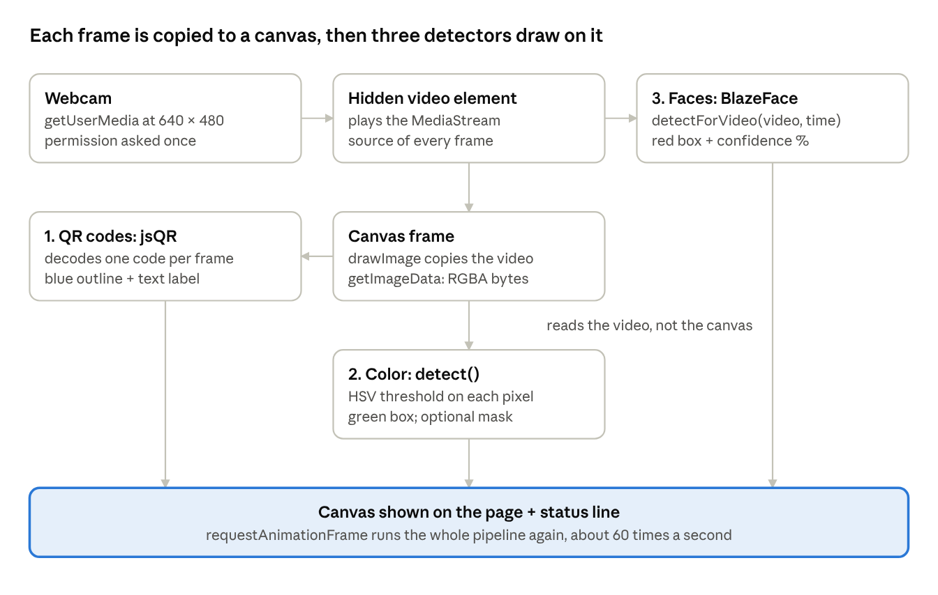
per-frame pipeline · 3 detectors, numbered in the order they run
The canvas is both the input for QR and color detection and the display. The face detector reads the video element directly.
Page elements:
Element | id | Role
Button | toggle | Calls start() or stop()
Color input | color | Target color as #rrggbb, default #ffff00 (yellow)
Checkbox | showMask | Show the black-and-white mask instead of the camera image
Checkboxes | enableColor, enableQr, enableFaces | Turn each detector on or off; read every frame, so changes apply at once
Canvas | output | Displays the frame and everything drawn on it
Div | status | One-line summary of what was found, or an error
Video (hidden) | video | Receives the webcam stream; never shown
Lifecycle: clicking Start calls start(), which opens the camera and begins loop(). loop() does its work for one frame, then asks the browser to call it again at the next screen refresh through requestAnimationFrame. Clicking Stop sets running to false, so the next loop() call returns immediately, and releases the camera.

Web version: function reference
All logic lives in one <script type="module"> block in index.html: eight functions and a handful of module-level variables.
Function | Inputs | Returns | What it does
rgbToHsv(r, g, b) | Three channel values, 0–255 | [h, s, v]: h 0–179, s and v 0–255 | Same formula and ranges as OpenCV's COLOR_BGR2HSV, so the thresholds carry over unchanged. Called once per pixel per frame.
getLimits(hexColor) | A #rrggbb string from the color picker | { hue, hueRange: 10, minS: 100, minV: 100 } | Port of util.get_limits. Parses the hex string, converts it to HSV and keeps only the hue; the other limits are fixed.
detect(imageData, limits, drawMask) | Canvas ImageData, the limits, a boolean | [x1, y1, x2, y2] or null | Replaces cv2.inRange + Image.getbbox in one pass: tests each pixel against the limits and tracks the minimum and maximum x and y of matches. With drawMask it also overwrites each pixel with white (match) or black. x2 and y2 are exclusive, as in Pillow.
loadFaceDetector() | none | A promise, shared by all callers | Loads MediaPipe's WebAssembly runtime and the BlazeFace model once. Later calls return the same promise. On failure it stores the message in faceDetectorError and does not retry.
drawLabel(text, x, y, color) | Label text, position, fill color | nothing | Draws a filled tag with black text just above (x, y), clamped so it never goes off the top of the canvas. Used for QR and face labels.
loop() | none | nothing | The per-frame pipeline (next section). Re-schedules itself with requestAnimationFrame while running is true.
start() | none | a promise | Requests the webcam with getUserMedia at 640 × 480, attaches it to the hidden <video>, sizes the canvas to the real video size, starts loading the face model and starts the loop. Shows the error in the status line if permission is denied.
stop() | none | nothing | Sets running to false, stops every camera track (the webcam light turns off) and resets the button.
Module-level state:
- stream: the active MediaStream, or null.
- running: whether loop should keep scheduling itself.
- faceDetector, faceDetectorLoading, faceDetectorError: the loaded detector, its pending load promise, and any load error.
- ctx: the canvas 2D context, created with willReadFrequently: true so the browser keeps pixels in CPU memory. This makes the getImageData call each frame faster.
Browser APIs used:
API | Replaces in Python | Role
navigator.mediaDevices.getUserMedia | cv2.VideoCapture(0) | Asks permission and opens the webcam. Works only on localhost or HTTPS.
HTMLVideoElement | cap.read() | Plays the live stream; each frame is copied from it.
CanvasRenderingContext2D.drawImage | (frame array) | Copies the current video frame onto the canvas.
getImageData / putImageData | NumPy frame array | Reads the frame as a flat RGBA byte array (4 bytes per pixel), and writes the mask back.
strokeRect, beginPath/lineTo/stroke, fillText | cv2.rectangle | Draws boxes, the QR outline and labels.
requestAnimationFrame | while True + cv2.waitKey(1) | Runs loop once per screen refresh, usually 60 times a second, pausing when the tab is hidden.

QR code and face detection
The browser version adds two detectors from outside libraries. The QR reader is classic image processing; the face detector is a small pre-trained neural network.

QR codes: jsQR 1.4.0
Loaded as a plain script from cdn.jsdelivr.net, which defines a global jsQR function (about 130 KB).
- Call: jsQR(frame.data, frame.width, frame.height, { inversionAttempts: 'dontInvert' }). It takes the same RGBA pixels the color detector uses.
- How it works: it converts the frame to black and white, finds the three square finder patterns in the corners of a QR code, corrects for perspective, and decodes the grid of modules.
- Option: 'dontInvert' skips a second pass that looks for light-on-dark codes. This saves a second full decoding attempt on frames with no code.
- Returns: null, or an object with data (the decoded text) and location (the four corners topLeftCorner, topRightCorner, bottomRightCorner, bottomLeftCorner, each {x, y}).
- Drawing: the four corners are joined into a blue polygon, so the outline follows a tilted code. The first 40 characters of the text are drawn as a label.
- Limit: it decodes one QR code per frame.

Faces: MediaPipe Tasks Vision 0.10.14 + BlazeFace
Imported as an ES module from cdn.jsdelivr.net. The model file (blaze_face_short_range.tflite, about 230 KB) comes from Google's model storage, and the WebAssembly runtime (about 9.4 MB) from jsDelivr.
- FilesetResolver.forVisionTasks(wasmUrl) locates and loads the WebAssembly runtime.
- FaceDetector.createFromOptions(vision, {...}) loads the model with:
  - runningMode: 'VIDEO': the detector expects a stream of frames with increasing timestamps and can reuse work between them.
  - minDetectionConfidence: 0.5: faces scored below 50% are dropped.
- Each frame, faceDetector.detectForVideo(video, performance.now()) runs the model directly on the <video> element and returns { detections }. Each detection has a boundingBox (originX, originY, width, height in pixels) and categories[0].score (0–1).
- Each face gets a red box and a label such as "Face 94%".
BlazeFace is Google's lightweight face detector built for mobile GPUs. The short-range model is tuned for faces within about 2 metres of the camera, which suits a webcam. It detects faces; it does not recognise who they are.

Order inside one frame
- QR detection runs first, because the mask view overwrites the frame's pixels.
- Color detection runs next and, if the mask is on, paints the mask onto the canvas.
- The QR outline and the face boxes are drawn last, on top of the frame or the mask.
The face detector reads from the <video> element, not the canvas, so the mask never affects it.

Python vs web, running it, and limitations
Every step of the Python loop has a direct counterpart in the browser; the web version only adds features on top.
Step | Python | Browser
Open camera | cv2.VideoCapture(0) | getUserMedia({ video: { width: 640, height: 480 } })
Grab frame | cap.read() → BGR NumPy array | drawImage(video) + getImageData → RGBA byte array
Convert to HSV | cv2.cvtColor(..., COLOR_BGR2HSV) | rgbToHsv() per pixel
Thresholds | util.get_limits(yellow) | getLimits(colorPicker.value)
Mask + box | cv2.inRange + Image.getbbox() | detect(), one pass
Draw box | cv2.rectangle(..., (0, 255, 0), 3) | ctx.strokeRect, green, 3 px
Display | cv2.imshow window | <canvas> on the page
Loop and exit | while True, waitKey, q key | requestAnimationFrame, Start/Stop button
Target color | Hard-coded yellow | Color picker, default yellow
Extras | none | Mask view, QR codes, faces, per-detector toggles

Running each version
- Python: pip install -r requirements.txt, then python main.py from ML/Color Detection. Press q in the window to quit.
- Browser: from ML/Color Detection/web, run python3 -m http.server 8765, open http://localhost:8765 and allow camera access. The page must be served from localhost or HTTPS for the webcam to work, and it needs internet access the first time to load jsQR, MediaPipe and the model.

Limitations
- One box for everything. Both versions draw a single box around all matching pixels, so two objects, or background noise of the same color, merge into one box. Finding separate blobs (cv2.findContours in Python, a connected-components pass in JavaScript) would give one box per object.
- No noise filtering. A few stray pixels stretch the box. A blur before thresholding, or erosion and dilation of the mask, would steady it.
- Fixed thresholds. ±10 hue and 100 minimum saturation and value suit bright, saturated colors under good light. Pale or dim objects are missed.
- Red never matches in Python (the wraparound bug above). Fixed in the browser version.
- Python ignores ret. If the camera fails to deliver a frame, frame is None and cv2.cvtColor raises an error instead of exiting cleanly.
- Browser speed. Color detection loops over about 307,000 pixels per 640 × 480 frame in JavaScript, and jsQR scans the full frame too. On slower machines this can drop the frame rate; turning off unused detectors helps.
- CDN dependency. The browser version loads its libraries and model from jsDelivr and Google. It will not work offline unless those files are downloaded and served locally.

